Logical Data Model

🌟 Definition
# Source: AI Source: Provided by: [Data Path: Persons Table -> ID Column: 1, Name_En Column: Motasem Essam] -> From: [ChatGPT] on [6/10/2026]
A Logical Data Model is a more detailed representation of data that defines:
- Entities
- Attributes
- Relationships
- Primary Keys
- Foreign Keys
- Data Structure
without focusing on the specific database system.
It describes how the data is organized logically, but not how it is physically stored.

🎯 Purpose
# Source: AI Source: Provided by: [Data Path: Persons Table -> ID Column: 1, Name_En Column: Motasem Essam] -> From: [ChatGPT] on [6/10/2026]
The Logical Data Model is used to:
- Convert business requirements into a structured design
- Define tables and columns
- Define relationships between tables
- Identify keys and constraints
- Prepare for physical database implementation

🧠 Key Question
# Source: AI Source: Provided by: [Data Path: Persons Table -> ID Column: 1, Name_En Column: Motasem Essam] -> From: [ChatGPT] on [6/10/2026]
A Logical Model answers:
How should the data be organized?
Not:
How will the database store the data on disk?

🔄 From Conceptual to Logical
# Source: AI Source: Provided by: [Data Path: Persons Table -> ID Column: 1, Name_En Column: Motasem Essam] -> From: [ChatGPT] on [6/10/2026]
Conceptual Model
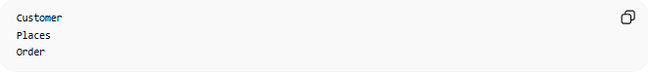
Customer
Places
Order
Only business concepts.

Logical Model
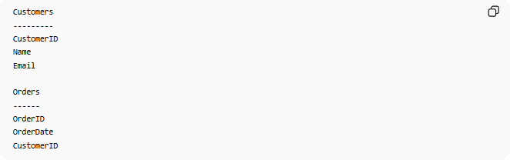
Customers
---------
CustomerID
Name
Email
Orders
------
OrderID
OrderDate
CustomerID
Now we define structure.

📚 Online Store Example
# Source: AI Source: Provided by: [Data Path: Persons Table -> ID Column: 1, Name_En Column: Motasem Essam] -> From: [ChatGPT] on [6/10/2026]
Entities
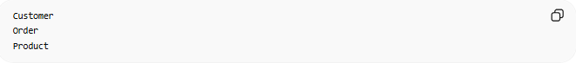
Customer
Order
Product

Logical Tables
Customers
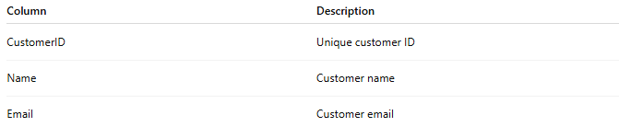
Column | Description
CustomerID | Unique customer ID
Name | Customer name
Email | Customer email

Orders
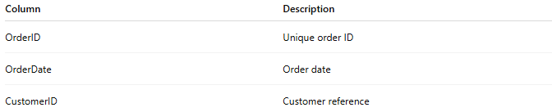
Column | Description
OrderID | Unique order ID
OrderDate | Order date
CustomerID | Customer reference

Products
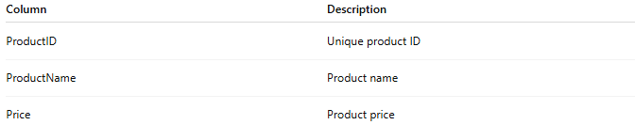
Column | Description
ProductID | Unique product ID
ProductName | Product name
Price | Product price

🧩 Main Components
# Source: AI Source: Provided by: [Data Path: Persons Table -> ID Column: 1, Name_En Column: Motasem Essam] -> From: [ChatGPT] on [6/10/2026]
1. Entities
Business objects become tables.
Example:
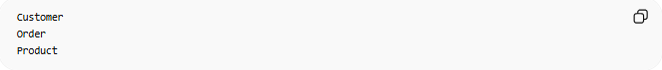
Customer
Order
Product

2. Attributes
Properties become columns.
Example:
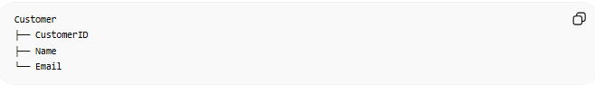
Customer
├── CustomerID
├── Name
└── Email

3. Relationships
Connections are defined.
Example:
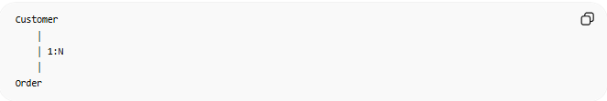
Customer
│
│ 1:N
│
Order

4. Primary Keys
Each table gets a unique identifier.
Example:
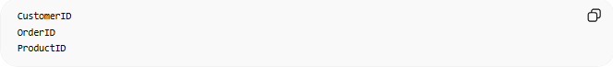
CustomerID
OrderID
ProductID

5. Foreign Keys
Relationships are implemented logically.
Example:
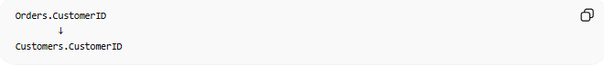
Orders.CustomerID
↓
Customers.CustomerID

📊 Logical ER Diagram
# Source: AI Source: Provided by: [Data Path: Persons Table -> ID Column: 1, Name_En Column: Motasem Essam] -> From: [ChatGPT] on [6/10/2026]
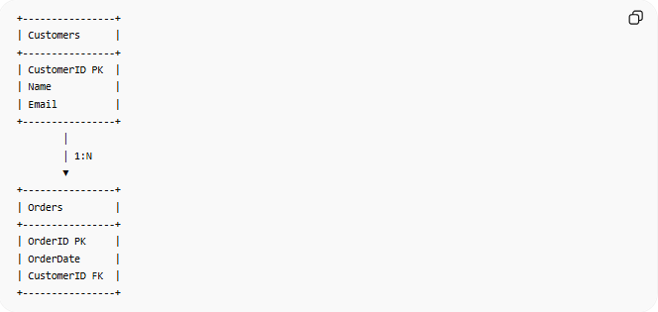
+----------------+
| Customers |
+----------------+
| CustomerID PK |
| Name |
| Email |
+----------------+
│
│ 1:N
▼
+----------------+
| Orders |
+----------------+
| OrderID PK |
| OrderDate |
| CustomerID FK |
+----------------+

🔢 Characteristics of a Logical Model
# Source: AI Source: Provided by: [Data Path: Persons Table -> ID Column: 1, Name_En Column: Motasem Essam] -> From: [ChatGPT] on [6/10/2026]
A Logical Model:
- Defines tables
- Defines columns
- Defines relationships
- Includes keys
- Independent of DBMS
- More detailed than a Conceptual Model

❌ What is NOT Included?
# Source: AI Source: Provided by: [Data Path: Persons Table -> ID Column: 1, Name_En Column: Motasem Essam] -> From: [ChatGPT] on [6/10/2026]
A Logical Model usually does NOT include:
Indexes
INDEX idx_customer
No.

Storage Files

.ibd
.mdf
.ndf
No.

Partitions
Partition by year
No.

Database-Specific Settings
MySQL Engine = InnoDB
No.

🌍 University Example
# Source: AI Source: Provided by: [Data Path: Persons Table -> ID Column: 1, Name_En Column: Motasem Essam] -> From: [ChatGPT] on [6/10/2026]
Conceptual Model

Student
Enrolls In
Course

Logical Model
Students

Column
StudentID
Name
Email

Courses

Column
CourseID
Title

Enrollment

Column
StudentID
CourseID

Relationship:
Students M:N Courses
implemented through:
Enrollment

🔄 Conceptual vs Logical
# Source: AI Source: Provided by: [Data Path: Persons Table -> ID Column: 1, Name_En Column: Motasem Essam] -> From: [ChatGPT] on [6/10/2026]
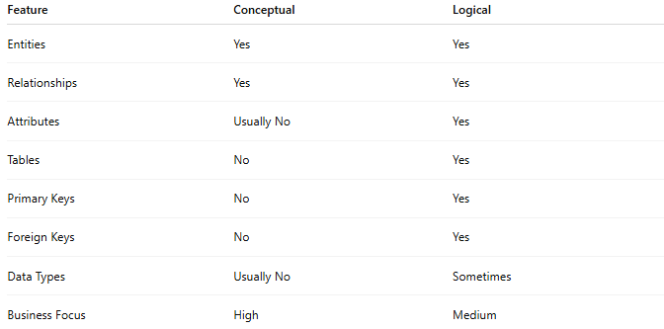
Feature | Conceptual | Logical
Entities | Yes | Yes
Relationships | Yes | Yes
Attributes | Usually No | Yes
Tables | No | Yes
Primary Keys | No | Yes
Foreign Keys | No | Yes
Data Types | Usually No | Sometimes
Business Focus | High | Medium

🔄 Logical vs Physical
# Source: AI Source: Provided by: [Data Path: Persons Table -> ID Column: 1, Name_En Column: Motasem Essam] -> From: [ChatGPT] on [6/10/2026]
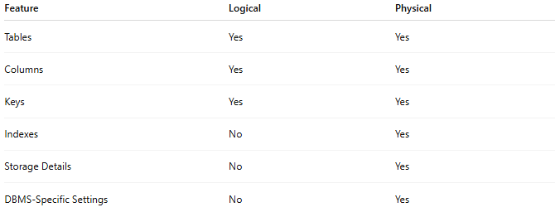
Feature | Logical | Physical
Tables | Yes | Yes
Columns | Yes | Yes
Keys | Yes | Yes
Indexes | No | Yes
Storage Details | No | Yes
DBMS-Specific Settings | No | Yes

📊 Example Progression
# Source: AI Source: Provided by: [Data Path: Persons Table -> ID Column: 1, Name_En Column: Motasem Essam] -> From: [ChatGPT] on [6/10/2026]
Conceptual
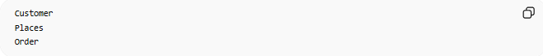
Customer
Places
Order

Logical
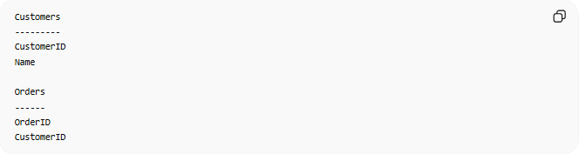
Customers
---------
CustomerID
Name
Orders
------
OrderID
CustomerID

Physical
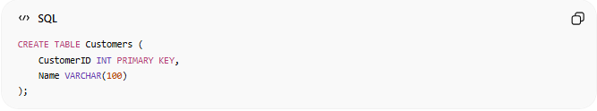
CREATE TABLE Customers (
CustomerID INT PRIMARY KEY,
Name VARCHAR(100)
);

🧠 Simple Analogy
# Source: AI Source: Provided by: [Data Path: Persons Table -> ID Column: 1, Name_En Column: Motasem Essam] -> From: [ChatGPT] on [6/10/2026]
Think of building a house.
Conceptual Stage

Kitchen
Bedroom
Bathroom

Logical Stage
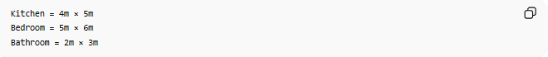
Kitchen = 4m × 5m
Bedroom = 5m × 6m
Bathroom = 2m × 3m
You define the structure but not the construction materials.

Physical Stage
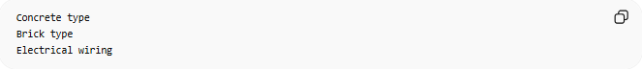
Concrete type
Brick type
Electrical wiring
Actual implementation details.

🧭 Summary
# Source: AI Source: Provided by: [Data Path: Persons Table -> ID Column: 1, Name_En Column: Motasem Essam] -> From: [ChatGPT] on [6/10/2026]
A Logical Data Model is a detailed representation of data that defines tables, attributes, relationships, primary keys, and foreign keys without focusing on a specific database system. It bridges the gap between business requirements (Conceptual Model) and actual database implementation (Physical Model).

